Blaxol Risensi LLP

Consulting Services Engagement Letter,

Rules for Engagement

Proposal for:

® Blaxol Risensi LLP (A Member of Blaxol LLC)

undefined undefined,

ENG - BLR

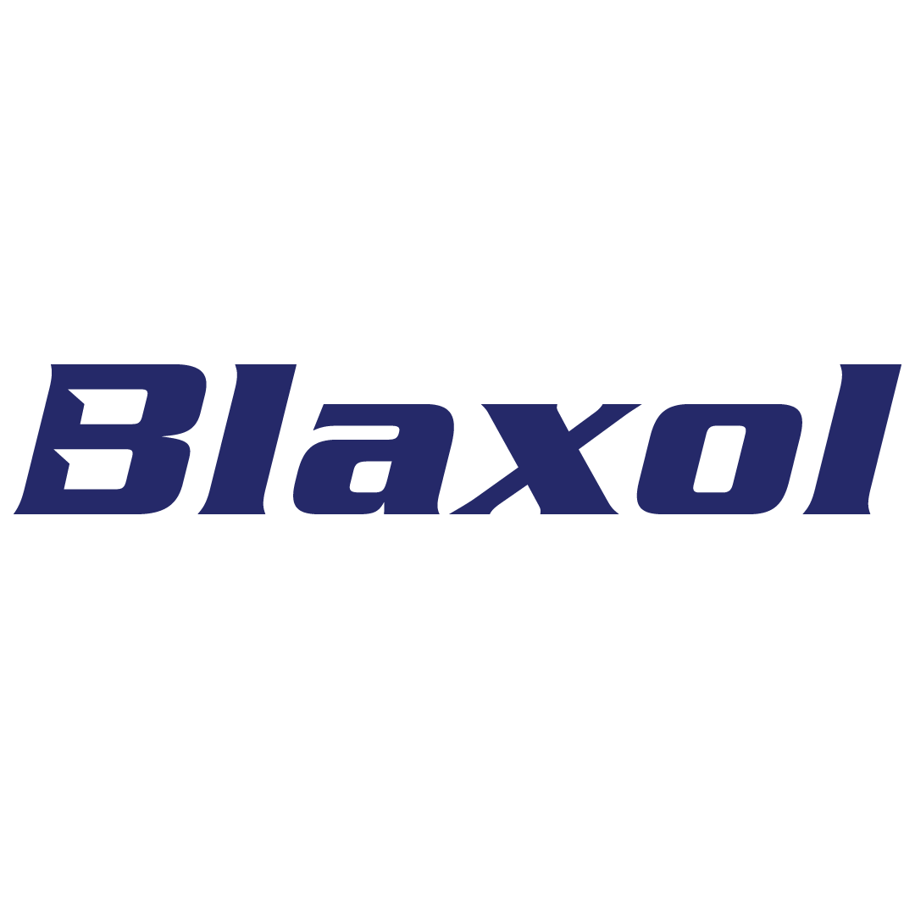

This proposal and contract are the property of Blaxol Risensi LLP (“Blaxol”) and must not be disclosed outside the family of or be duplicated, used, or disclosed—in whole or in part—for any purpose other than to evaluate this proposal. If a contract is awarded to Blaxol as a result of, or in connection with, this proposal, the Promoters shall have the right to duplicate, use, or disclose the data to the extent provided in the resulting contract and subject to the limitations of the Privacy Policy and other applicable bylaws. This proposal contains trade secrets and proprietary commercial or financial information, and information of a personal nature that is exempt from disclosure under OPRAA and other applicable laws.Accordingly, no portion of this document should be released without consulting BLAXOL. This information is contingent on the Parties reaching mutually agreeable terms and conditions and upon acceptance of any limitations described herein

#30, 2 nd Floor, 4 th Main Road,

Jayanagar 7 th Block, Bengaluru,

Karnataka, India 560070

undefined undefined,

Attn:

India 110070

Subject: Letter of Intent / Declaration and Explanation

**Exhibit A**

**Key Personnel Information**

|  |  |  |  |  |
| --- | --- | --- | --- | --- |
| **Name** | **Designation** | **Organisation** | **Email** | **Mobile** |

**Fund Manager Declaration**

FOR BLAXOL RISENSI LLP

Managing Partner